Estimation Techniques

📌 What are Estimation Techniques?
# Source: Chatgot (GPT-5-Standard) at [8/17/2025]
Estimation Techniques in software testing are methods used to predict the effort, time, cost, and resources needed for testing activities.
👉 In short:
They help answer “How long will testing take?” and “How many people/resources are needed?”
Good estimation helps in:
- Planning test activities
- Allocating resources
- Setting realistic deadlines
- Managing risks and costs

🎯 Common Estimation Techniques in Software Testing

1. Work Breakdown Structure (WBS)
# Source: Chatgot (GPT-5-Standard) at [8/17/2025]
- Testing tasks are broken down into smaller sub-tasks.
- Estimate each sub-task → then add them up.
✅ Example:
- Test Planning = 8 hrs
- Test Case Design = 20 hrs
- Test Execution = 40 hrs
- Defect Retesting = 12 hrs
- Total = 80 hrs

2. Expert Judgment
# Source: Chatgot (GPT-5-Standard) at [8/17/2025]
- Estimation based on the experience of senior testers or managers.
- Useful when similar projects were done before.
✅ Example:
- A test manager recalls a similar e-commerce project took ~200 hrs.
- Adjusts based on new complexity → 220 hrs.

3. Three-Point Estimation (PERT Technique)
# Source: Chatgot (GPT-5-Standard) at [8/17/2025]
Uses 3 values to calculate realistic estimates:
- O (Optimistic) – best case
- M (Most Likely) – normal case
- P (Pessimistic) – worst case
Formula:
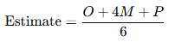
Estimate=O+4M+P6\text{Estimate} = \frac{O + 4M + P}{6}
✅ Example:
- O = 10 hrs, M = 15 hrs, P = 30 hrs
- Estimate = (10 + 4×15 + 30) ÷ 6 = 16.67 hrs

4. Function Point Analysis (FPA)
# Source: Chatgot (GPT-5-Standard) at [8/17/2025]
- Estimates effort based on functionality size (inputs, outputs, user interactions, files, etc.).
- More functionality → more testing effort.
✅ Example:
- Login (5 pts), Payment (10 pts), Reporting (15 pts).
- Total = 30 Function Points → 3 hrs per FP = 90 hrs testing.

5. Use Case Point (UCP)
# Source: Chatgot (GPT-5-Standard) at [8/17/2025]
- Similar to FPA but based on use cases.
- Factors in complexity of actors & transactions.
✅ Example:
- Simple Actor = 1 pt, Complex Actor = 3 pts.
- Simple Use Case = 5 pts, Complex Use Case = 15 pts.
- Multiply by productivity factor → final estimate.

6. Test Point Analysis
# Source: Chatgot (GPT-5-Standard) at [8/17/2025]
- Special for test cases.
- Effort is based on number of test cases × complexity factor.
✅ Example:
- 100 test cases × 1 hr each = 100 hrs.
- If 20% are complex → +20 hrs.
- Total = 120 hrs.

7. Wideband Delphi Technique
# Source: Chatgot (GPT-5-Standard) at [8/17/2025]
- A group of experts give estimates independently.
- Then discuss differences and refine until consensus is reached.
✅ Example:
- Expert A: 150 hrs, Expert B: 200 hrs, Expert C: 180 hrs → After discussion, agree on 185 hrs.

8. Percentage of Development Effort
# Source: Chatgot (GPT-5-Standard) at [8/17/2025]
- Testing is estimated as a fixed percentage of development time.
✅ Example:
- If development = 1000 hrs, testing = 30% → 300 hrs.

📊 Comparison of Estimation Techniques
# Source: Chatgot (GPT-5-Standard) at [8/17/2025]
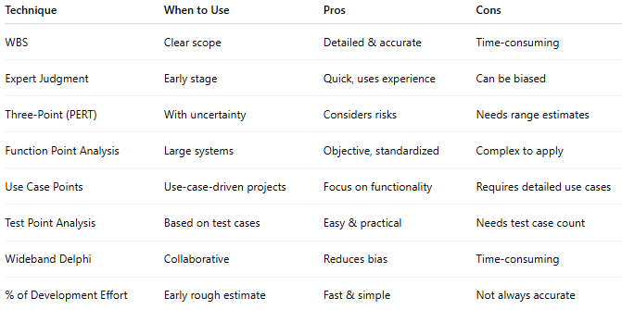
Technique | When to Use | Pros | Cons
WBS | Clear scope | Detailed & accurate | Time-consuming
Expert Judgment | Early stage | Quick, uses experience | Can be biased
Three-Point (PERT) | With uncertainty | Considers risks | Needs range estimates
Function Point Analysis | Large systems | Objective, standardized | Complex to apply
Use Case Points | Use-case-driven projects | Focus on functionality | Requires detailed use cases
Test Point Analysis | Based on test cases | Easy & practical | Needs test case count
Wideband Delphi | Collaborative | Reduces bias | Time-consuming
% of Development Effort | Early rough estimate | Fast & simple | Not always accurate

🔑 Summary
# Source: Chatgot (GPT-5-Standard) at [8/17/2025]
- Estimation = predicting testing effort, time, cost, resources.
- Techniques include: WBS, Expert Judgment, Three-Point, FPA, UCP, Test Point, Wideband Delphi, % of Dev Effort.
- Choice depends on project size, available data, and uncertainty.

